Working with Documents - Exercise!
Welcome to your first document base assignment. In this document you will learn how to organize a document.
Here is a checklist of what you will learn today. Each one that you master, add an X in the () like this (X).
New Document () | Save and Save As () | Fonts () | Font Size () |  | Bold()
Italics () | Underline () | Alignment() | Indenting () |  | Line Spacing ()
Spelling()

New Document
The first and most important thing is to create a new document. Click on in the top left, and select File. Choose New, and then New Blank Document. You can also do this by press Ctrl+N.

Save and Save As
Next up we want to SAVE the document. Saving means that you want to keep the file in your computer. In the top left corner, click the to save. It will ask you where you want to save it, and what its name is. Save the file as your name. This is the most important thing you will learn about working on the computer.
SAVE AS is when you want to save the file with a different file name, file type (file format) or in a different location. Click on in the top left, and select File. Choose Save As, and choose Microsoft Word 2007-2010 Document. Another way is pressing F12. Make sure you save the document as Word Assignment 1.
Preparing for Work
Copy and paste the following into the document:
My First Word Worksheet
Bold Italic Underline
Left
Right
Center
And finally, have this justified align, which only will happen if this sentence will be sufficiently long enough.
To be or not to be, that is forever the question yo. Whether ‘tis nobler in the mind to suffer the slings and arrows of being basic, or to take arms against my homeboys, and by opposing, crushing it. To die, to lie like a dead log, no more.
Haxxor, a yung litle boy, needed to go. He had to go relly bad.

Fonts
Fonts are different style of words. To change the style, select the TITLE (the name of the document). Click on the home tab 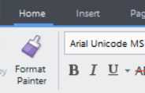. Now use the pull down tab and select a style you like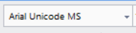. For the title, choose a font that looks nice to you. Now do the same for the rest of the text, and choose a font like Times New Roman, or Arial.
Save your work.
Copy and paste the following into your document:

Font Size
Size is a way to make words BIG or small. Choose the pull down tab beside the font and change the title to a size 18 font. Change all other text to size 12 font.

Bold Italics and Underline
BOLD means to make the letters thicker. Select the word bold and click to make it bold.
ITALICS means to make the letters look slanted. Select the word italics and click to make it italicized.
UNDERLINE means to create a line under the words. Select the word underline and click to make it underlined.

Alignment
Alignment makes the words appear in different spaces.
Left align makes the words start from the left.
Center align makes the words start from the center.
Right align makes the words start from the right.
Justified alignment makes the words take up the entire line when words are supposed to take up an entire line. You will find this in newspaper articles. In most of the other writings that we do, we do not use justified align because it may make some writing look strange.
In your document, center align the word center.
Right align the word right.
Make the sentence about justified alignment justified.
Save your work.

Indenting and Spacing
Indenting creates space in front of a text. Line spacing 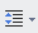 makes room between each line. Line spacing is important for handing in writing in most English assignments, because it is easier to read and make changes.
Indent the first paragraph. Make everything 2.0 (double) spaced.
Save your work.

Spelling
Spelling is important in all languages. Click on the Review tab 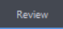 and choose Spell Check 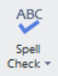. You will see something come up like this:
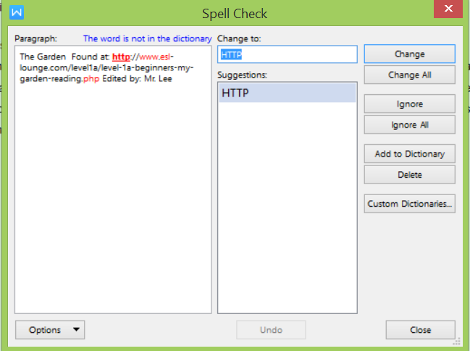
Sometimes, it will give you words you do not need to change (for example, my website address does not need to change). You can click the Ignore button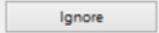 .
Sometimes, you will need to make a change. You can type into the box 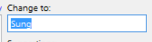 or click one of the suggestions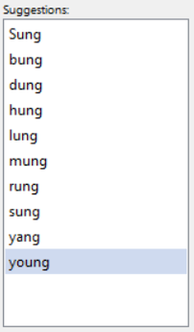. Then, you will click the Change button to change it.
Once you are done all changes, you can click Close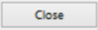.
Correct only the words in the line: Haxxor, a yung litle boy, needed to go. He had to go relly bad.
Make sure all the words are corrected.

